McConnell Mansion: A Self-Guided Tour
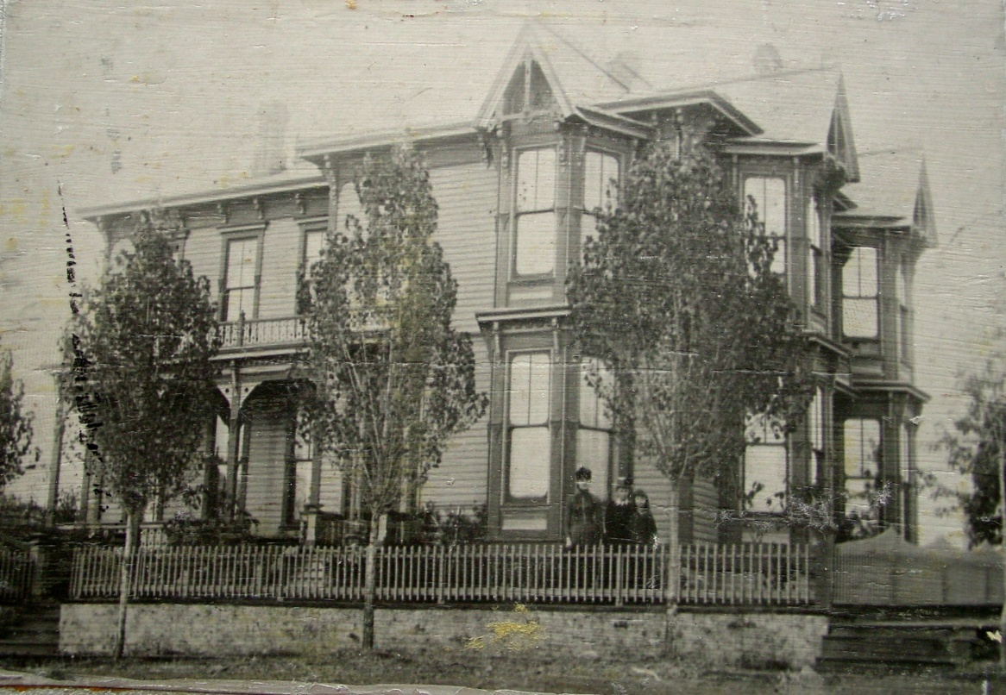

HISTORY OF THE HOME
On a cold, snowy Christmas Eve in 1886, a sleigh pulled up in front of Moscow’s newest and grandest house on the corner of Second and Adams Streets. The sleigh’s passengers were William and Louisa McConnell and their five children. Inside, Allen Ramstedt, neighbors, and friends had gathered for a royal house warming.
This is a Victorian Gothic home built in 1886 for approximately $6,000, including some furnishings. It is a mixture of architectural styles, Queen Anne and Eastlake, both characteristic of the late 1800s. Architecturally, the McConnell Mansion is important since no other home in the Eastlake style has survived in Idaho. The McConnell Mansion Museum was added to the National Register of Historic Places in November of 1974.
The McConnells were the first owners, but not the last.
Owners of the home:
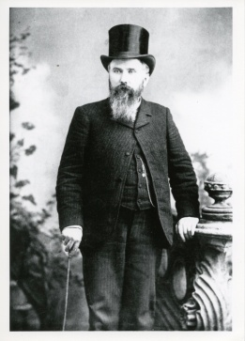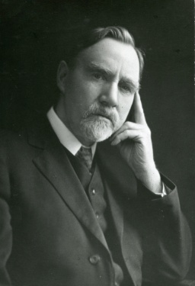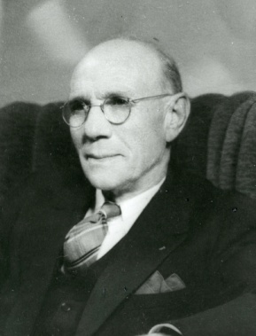
William J. McConnell Dr. William Adair Thomas L. Jackson Dr. Frederic Church
William J. McConnell – 1886-1897
wife Louisa, children Ben, Mary, William, Ollie May, Carrie
Dr. William Adair – 1901-1933
wife Losina, children Ione, Lulu, Flora, Bernadine, Marjorie
Thomas L. Jackson – 1935-1941
wife Agnes, children Helen, Richard
Dr. Frederic Church – 1941-1965

The home was donated to Latah County by its last owner, Dr. Frederic Church, in 1966. “Dr. Church…told me of is hope that the mansion as a gift would be accepted from him…” – Clara M. Grove

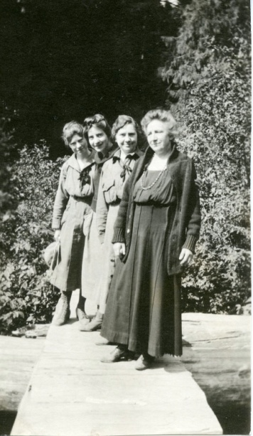
So his wonderful gift was accepted, and many people gave time and more to make this museum what it is now. While there are original items in the home, the majority of the furnishing were donated by descendants of early Latah County families.

A GUIDE TO THE HOME
Entry: As you enter, notice the Victorian floor plan consisting of a long hall with doors leading to separate rooms, and the original entry door with etched, colored glass squares. The door you entered once led to a glass conservatory constructed on today’s porch.
Front Parlor: This room was used for special occasions, as a space to welcome guests, and to display family heirlooms. It was here, in 1904, that Lulu Adair was married. An in the south bay windows, Bernadine Adair performed – opening the red velvet draperies, bowing, and then singing for her mother.
Ione, Bernadine,
Marjorie & Losina
Back Parlor: Note the coal burning fireplace and mantel with Vermont marble veneer beneath Governor William McConnell’s official portrait. At one time, eleven stoves were used to heat the home, and in the 1920s, a coal furnace with a stoker was installed. Ellen Chandler, a boarder when Mr. Jackson owned the home, was proposed to by her future husband here in the back parlor.
Downstairs, Back Room: In the 1930s William and Losina Adair converted part of the back porch to create this room. Mrs. Adair slept here due to failing health from tuberculosis. Dr. Church also used this room, where he slept on an old-fashioned rope bed.
Kitchen: Here you are in the 1930s kitchen with a range that burned either wood or coal. A narrow staircase that led from the kitchen to the upstairs was removed during the conversion by the Adairs. In this sunny kitchen, Dr. Church prepared Sunday breakfast for his boarders. On the wall above the sink there is an exposed square revealing lath and plaster construction.
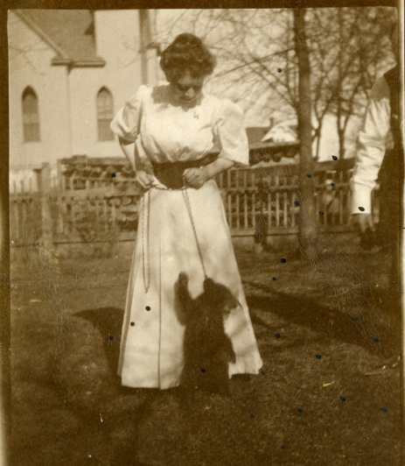
Pantry: Phyllis Gibson, granddaughter of the Adairs, remembers sitting on the counter while Losina sang hymns and baked. One day, grandmother Adair broke into a rousing version of “Little Brown Jug” and they laughed and laughed. If you look carefully at the bottom of the wooden shutter, you will see the initials “MMc” scratched into the wood – a reminder of the many generations that lived and loved here.
Dining Room: William Adair made the Tiffany-style lamp that hangs over the table where dinners with many guests were served. One day, the Adairs’ pet, an orphaned bear cub named Birch, escaped his tether in the back yard and was chased through the house, leaving a scratch on top of the table. They later called firemen when the bear was tangled by his chain in the front maple tree, and required a rescue.
Lulu Adair & pet bear Birch
Hired Girl’s Bedroom: Imagine the life of a young woman who had immigrated to Moscow from Sweden. Her domestic lifestyle is evoked by the presence of the sewing basket and stand, and postcards and books written in Swedish. There are stories that the front window in this room was used to access the glass conservator on the porch.
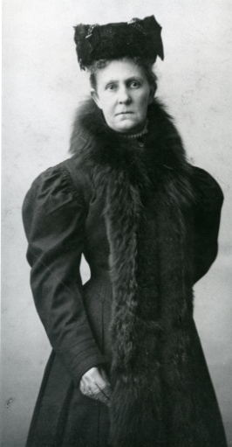
Family Bathroom: This home was the first in Moscow to be built with indoor plumbing using a windmill pump. Until the windmill was fully functioning, you would pull the cord inside and then rush outside to pump water. Or you could prevail upon the person waiting next in line.
Glass Conservatory: The northern section of the front porch was once enclosed in glass. This area housed plants, flowers, as well as a parrot given to Louisa by friends. It was said the parrot squawked one night, waking the family to a fire that had begun on an interior wall.
Staircase: Imported oak from San Francisco, this banister was shipped up the Columbia River to Walla Walla and then transported to Moscow by horse and wagon. Phyllis Gibson recalled how her grandmother Adair would allow her to slide down the banister, if she held a dust cloth in her hands.
Louisa McConnell
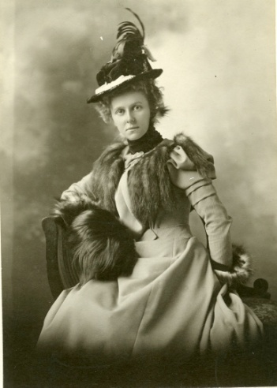
Upstairs Bedrooms: Marjorie Adair lived at the top of the stair in the room with the balcony facing South. Dr. Cogswell, head of the University of Idaho Music department and Dr. Wilkie Collins, English professor, both rented rooms upstairs. Renowned author Carol Ryrie Brink later wrote of her experiences visiting the house as a music student.
The front bedroom had a large closet thought to be a dressing room. “There were moths that ruined several suits of one of the teachers living upstairs and an inexpensive skirt I had made myself.” – Nelda Leslie
In the master bedroom, woodwork was painted and hand grained to resemble golden oak. The mahogany bedstead, dresser, and commode were donated by the Nelsons, a Latah County pioneer family. There were several boarders who lived in the home while it was owned by the Jackson family: Miss Belle Sweet, a librarian, and Dr. Gurney, a Physics professor, among others. The house was a lively center of activity with university club meetings, literary discussions, and music recitals.
Mary Borah
Mary McConnell Borah, the governor’s daughter, lived to 105 years of age. Here memorial service was held on a sunny Sunday, January 18, 1976. Many Moscow people gathered at the McConnell Mansion in memory of Mary, many years a wife, and many more years the widow of William E. Borah, famous U.S. Senator from Idaho.
Would you like to learn more about the house, the people who lived here, or the history of Latah County? Please visit our research library located in the Centennial Annex across the street at 327 East Second Street. Our office is open Tuesday – Friday from 9:00 a.m. to 5:00 p.m.
Thank you for visiting! Please come back with family and friends to share the McConnell Mansion. We also invite you to join us for events such as our Victorian Tea, Ice Cream Social, and Victorian Holiday.
The museum is open Tuesday – Friday (and some Saturdays) 1:00 to 4:00 p.m. Other times can be arranged; please call the office at 208.882.1004, email lchslibrary@latah.id.us, or visit our website, www.latahcountyhistoricalsociety.org.
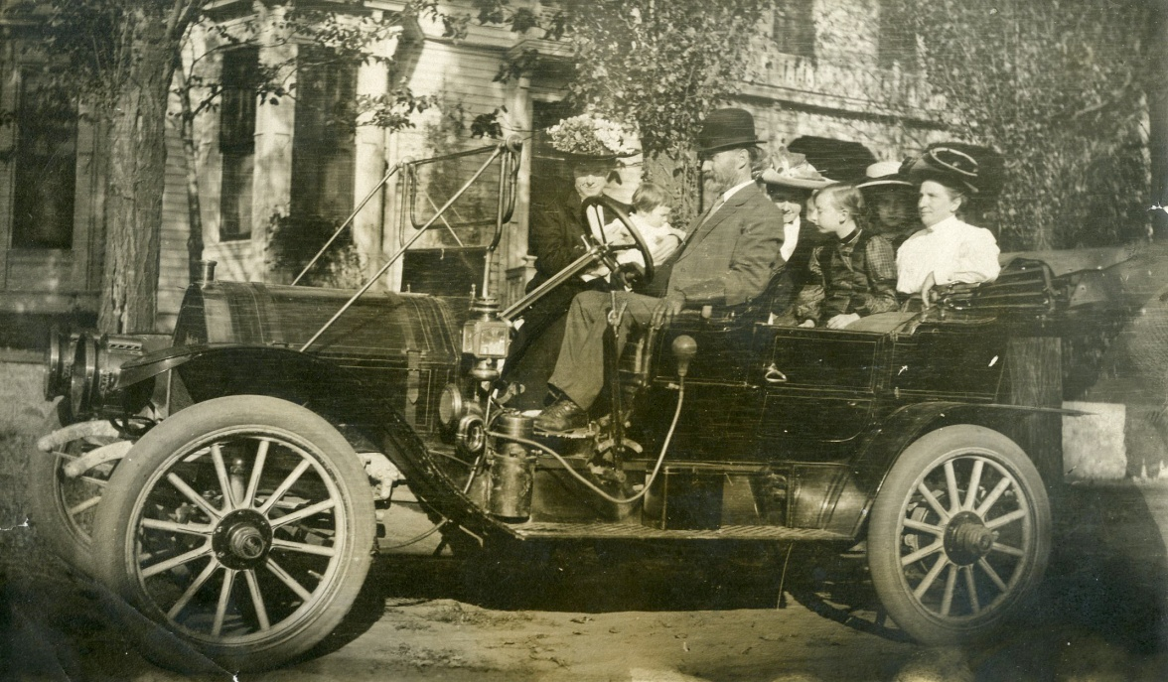
The Adair Family Car 1910

